MID-WESTERN CITY HOUSING

REPORT & PREDICTIONS

By

Prateek Goyal

A REPORT

Submitted as a Self-Evaluation Project for the degree of

MASTER OF SCIENCE

In Data Science

MICHIGAN TECHNOLOGICAL UNIVERSITY

2019

© 2019 Prateek Goyal

This report has been submitted as a Self-Evaluation Project for the Degree of MASTER OF SCIENCE in Data Science.

Data Science

Report Advisor: *Prof.* *Dr.* Jianping Dong

Department Director: Prof. Dr. Laura E. Brown

Table of Contents

List of Tables and Figures iv

Acknowledgements vi

Abstract vii

1 Main body 1

1.1 Getting the dataset into SAS environment 1

1.1.1 Importing Dataset 1

1.1.2 Verify the dataset 2

1.1.3 Know your dataset 3

1.2 Summarizing Your Data with Descriptive Statistics 5

1.2.1 The MEANS Procedure 5

1.3 Data Visualization 11

1.3.1 The UNIVARIATE Procedure 11

1.3.2 The PROC PLOT Procedure 17

1.3.3 The PROC SGPLOT Procedure 19

1.4 Preparing the Input Variables for Prediction 21

1.4.1 Missing values 21

1.4.2 Detecting and removing outliers 22

1.4.3 Correlation between variables 24

1.5 Model Selection 26

1.5.1 Forward Stepwise Procedure 27

1.5.2 Forward Selection Procedure 28

1.5.3 Backward Elimination Procedure 30

Copyright documentation 34

###### List of Tables and Figures

Figure 1: Table metadata showing all 13 variables and their description. vii

Figure 2: Displaying first 10 rows showing all the variables of the dataset. 2

Figure 3: Displaying the details of the variables of the dataset. 4

Figure 4: Summary measures for all the independent variables in the dataset. 5

Figure 5: Summary measures for all the independent variables in the dataset by Number of Bedrooms. 8

Figure 6: Summary measures for all the independent variables in the dataset by Adjacent to Highway. 10

Figure 7: Displaying the UNIVARIATE Procedure output. 16

Figure 8: Displaying the scatter plot for Sales Price vs. Finished Square Feet. 18

Figure 9: Displaying the SGPLOT Procedure output. 20

Figure 10: Displaying the missing values for all the regressor parameters. 22

Figure 11: Dataset before removing outliers 23

Figure 12: Dataset after removing outliers 24

Figure 13: Displaying correlation between regressor variables and dependent variables. 25

Figure 14: Displaying the final regressor subset using the Forward Stepwise Procedure. 28

Figure 15: Displaying the final regressor subset using the Forward Selection Procedure. 29

Figure 16: Displaying the final regressor subset using the Backward Elimination Procedure. 31

Figure 17: Displaying the rejected regressor subset using the Backward Elimination Procedure. 31

###### Acknowledgements

Writing this report is harder than I thought and more knowledge rewarding than I could have ever imagined. None of this would have been possible without my Professor, Dr. Jianping Dong. Thank you, Professor, for your enriching Regression Analysis class in my 1st Semester. And, thank you Pratik Adyalkar and Rajath Nagaraj for discussing various concepts late nights during the whole semester; helped me in gaining knowledge around various topics. Thank you all!

###### Abstract

The city tax assessor was interested in predicting residential home sales price in a mid-western city as a function of various characteristics of the home and surrounding property. Data on 522 arms-length transactions were obtained for home sales during the year 2002. Each line of the data set has an identification number and provides information on 12 other variables. The 13 variables are:



Figure : Table metadata showing all 13 variables and their description.

# Main body

Multiple linear regression is one of the most widely used of all statistical methods to predict a dependent variable based on the number of independent/predictor variables. In this project, we will illustrate descriptive analysis, inferential analyses, and residual analyses, fit our dataset into Generalized linear model, then we will discuss on how to predict the best subset of regressors for predicting the sales price (dependent variable) using various model selection methods.

## Getting the dataset into SAS environment

### Importing Dataset

To import the dataset into the SAS environment, there are several ways mentioned below.

1. ‘Infile’ command in the data part
2. Proc import
3. Data Import dialog box

We will be using the 1st method to import our dataset which is mentioned below.

Note: The delimiter used in the data.csv file is single white spaced.

libname libref 'D:\MTU\Courses\Regression_Analysis_MA_4710\SAS_code\dataset\lib';

filename fileref 'C:\Users\prtk1\Desktop\Predictive Analysis SAS\RealEstate.csv';

**data** libref.re;

infile fileref;

input Identification_number

Sales_price

Finished_square_feet Number_of_bedrooms

Number_of_bathrooms

Air_conditioning

Garage_size

Pool

Year_built

Quality

Style

Lot_size

Adjacent_to_highway;

**run**;

A LIBNAME statement is one of those global statements that does not occur in a data step or a proc step. The format of the LIBNAME statement is:

LIBNAME libref 'File path name here';

Here the first word (LIBNAME) is the SAS keyword that tells it to create a library.

The FILENAME statement associates a SAS fileref (a file reference name) with an external file's complete name (directory plus file name). The format of the FILENAME statement is:

FILENAME fileref 'File path name here';

The fileref is then used as a shorthand reference to the file in the SAS programming statements that access external files (INFILE, FILE, and %INCLUDE).

INFILE statement specifies an external file to read with an INPUT statement.

### Verify the dataset

To verify the dataset read above, we have a dedicated proc statement mentioned below to print the dataset on the SAS output console.

Code snippet:

**proc** **print** data=libref.re;

**run**;

Output:

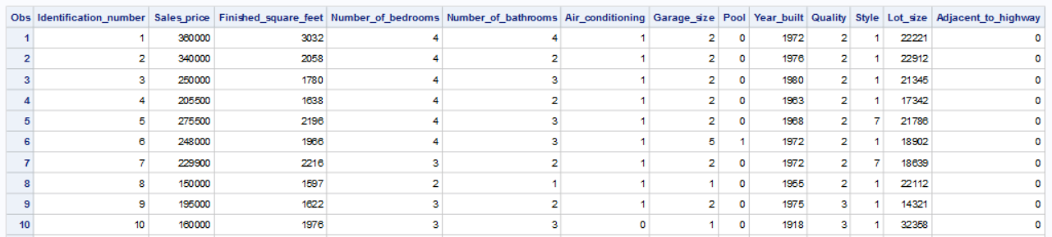

Figure : Displaying first 10 rows showing all the variables of the dataset.

### Know your dataset

The CONTENTS procedure generates summary information about the contents of a dataset, including:

* The variables' names, types, and attributes (including formats, informats, and labels)
* How many observations are in the dataset
* How many variables are in the dataset
* When the dataset was created

Code Snippet:

**proc** **contents** data=libref.re;

**run**;

Output:

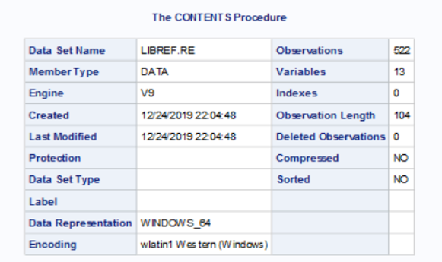

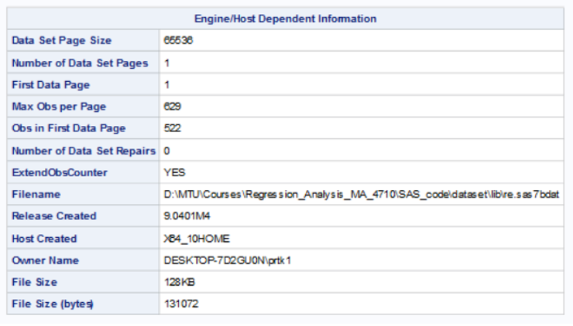

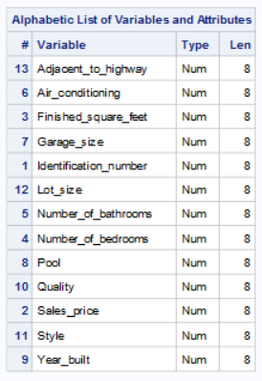

Figure : Displaying the details of the variables of the dataset.

## Summarizing Your Data with Descriptive Statistics

In this section, we will focus on measures of center, spread, and shape for summarizing numeric data and how to produce these measures across various groups of interest. These types of data descriptions are critical for understanding data and provide the foundations for both data visualization and inferential statistics.

### The MEANS Procedure

The MEANS procedure is employed for reporting summary measures, or descriptive statistics, for numeric data. In particular, the means procedure produces measures of center, variation, and shape, in addition to quantiles and confidence limits for the mean. The procedure can also be used for identifying extreme values and performing t-tests. The procedure allows for separating the analyses on various grouping variables for comparison purposes. Finally, the means procedure also provides the option to save the descriptive statistics to a separate SAS data set for future reference.

Code snippet:

**proc** **means** data=libref.re n mean max min range q1 mode median q3 qrange

std n nmiss skew kurtosis clm t maxdec=**2**;

TITLE 'Description Of Real Estate Dataset';

**run**;

Output:

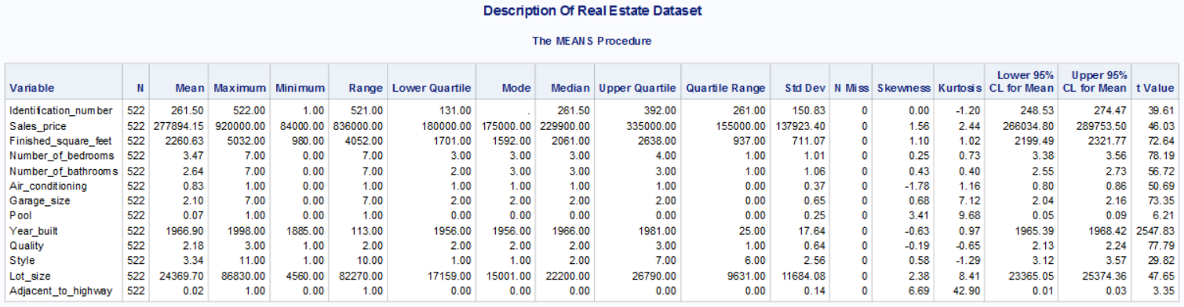

Figure : Summary measures for all the independent variables in the dataset.

After analyzing the above table, a various question arises. What is the average price for a 3-bedroom house? What is the average sales price for having a pool in the house? What is the maximum price for a house having a maximum number of bedrooms? What is the average sales price for the house which is adjacent to Highway?

To answer all the questions mentioned above, we need to tweet the above code snippet a little bit by adding a class statement inside the proc statement to get the answers to our questions. Below shows some of the analyses based on a specific regressor variable.

Note: The below code shows default summary statistics for the dataset.

Code snippet:

**proc** **means** data=libref.re maxdec=**2**;

class Number_of_bedrooms;

TITLE 'Description Of Real Estate Dataset by Number of bedrooms';

**run**;

Output:

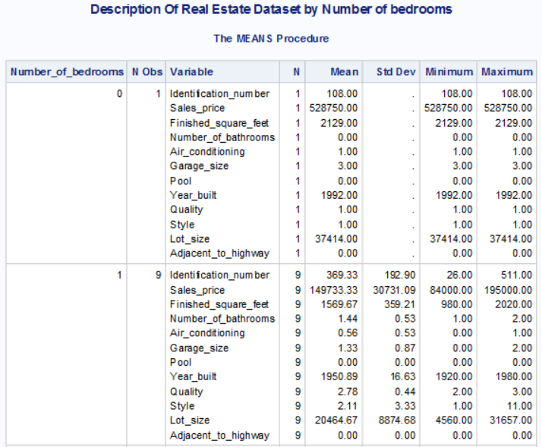

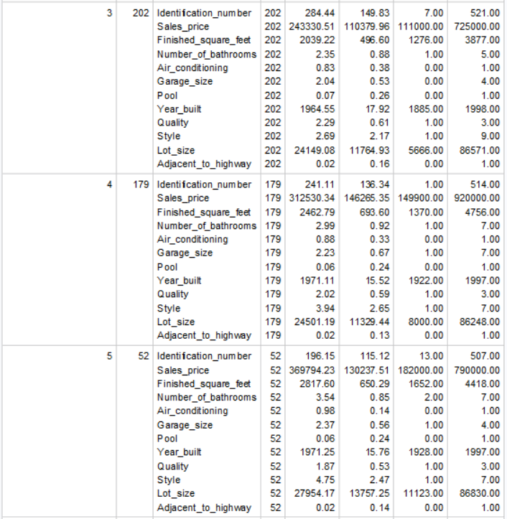 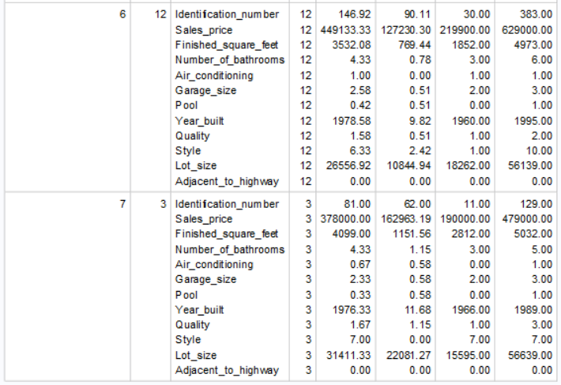

Figure : Summary measures for all the independent variables in the dataset by Number of Bedrooms.

Code Snippet:

**proc** **format**;

value yesno **0**=No **1**=Yes;

**run**;

**proc** **means** data=work.re_sort_year maxdec=**2**;

class Pool;

format Pool yesno.;

TITLE 'Description Of Real Estate Dataset by Pool';

**run**;

Output:

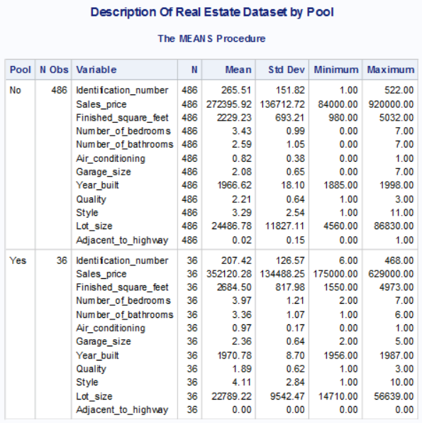

Table: Summary measures for all the independent variables in the dataset by Pool.

Code snippet:

**proc** **means** data=work.re_sort_year maxdec=**2**;

class Adjacent_to_highway;

format Adjacent_to_highway yesno.;

TITLE 'Description Of Real Estate Dataset by Adjacent to

highway';

**run**;

Output:

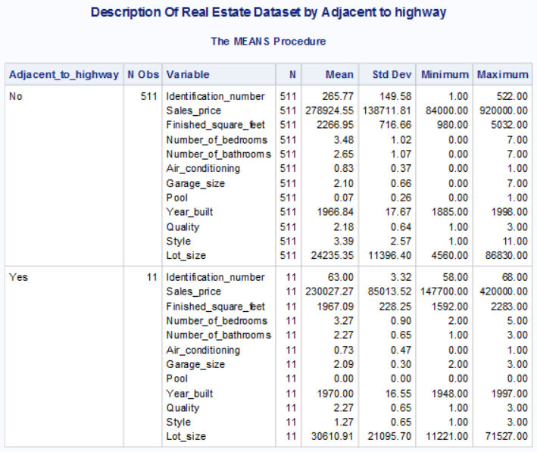

Figure : Summary measures for all the independent variables in the dataset by Adjacent to Highway.

## Data Visualization

In this era of Big Data, where data sources comprise millions of rows and hundreds - or even thousands - of columns, it is impossible to visualize or make any summary statements about the data. Therefore, the data analyst must employ exploratory data analyses as a way of reducing mounds of data into manageable numeric summaries and pictures which are much more easily interpreted. Tukey’s emphasis was on the visual aspects of data summaries, topics that are the center of discussion in this section.

### The UNIVARIATE Procedure

The UNIVARIATE procedure produces five tables of summary information, as seen in Output 3.7 Univariate Statistics on BMI for 200 Diabetic Patients, four of which are for descriptive purposes and will be discussed here. Each of the tables provides for the following:

1. The first three tables provide various descriptive summaries described in previous sections. Specifically, those tables include measures of center (mean, median, and mode), dispersion (range, variance, and standard deviation), and shape (skewness and kurtosis). The interquartile range represents the range of the middle 50 percent of the data.

2. The fourth table tests for location, provides for inferential tests and will be discussed later.

3. The fifth table, referred to as Quantiles, lists the numeric values that represent the location along the x-axis (minimum, maximum, percentile, and quartiles). It should be noted that the interquartile range is the difference between Q1 and Q3.

4. The last table provides a list of the extreme values, specifically, the five smallest values and the five largest values.

PROC UNIVARIATE also used to create histograms, normal probability plots, and box-and-whisker plots for numeric variables.

Code snippet:

**proc** **univariate** plots;

var Sales_price

Finished_square_feet

Number_of_bedrooms

Number_of_bathrooms

Air_conditioning

Garage_size

Pool

Year_built

Quality

Style

Lot_size

Adjacent_to_highway;

histogram / vscale=count normal kernel;

qqplot/normal (mu=est sigma=est);

**run**;

Output:

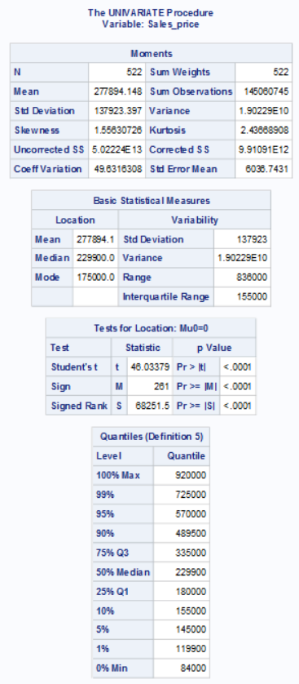

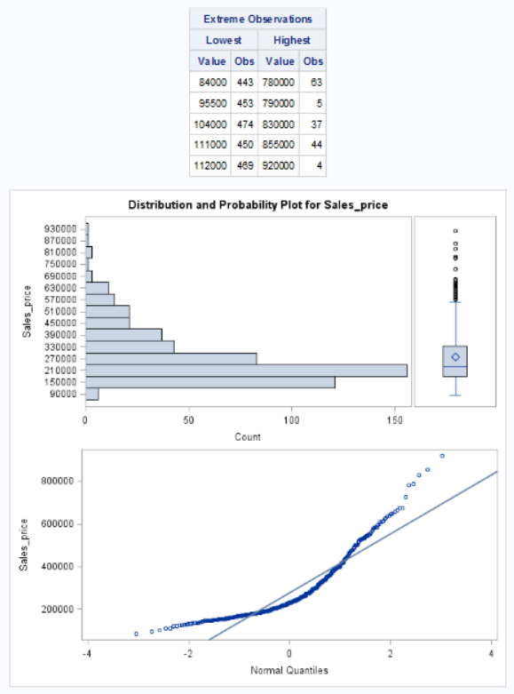

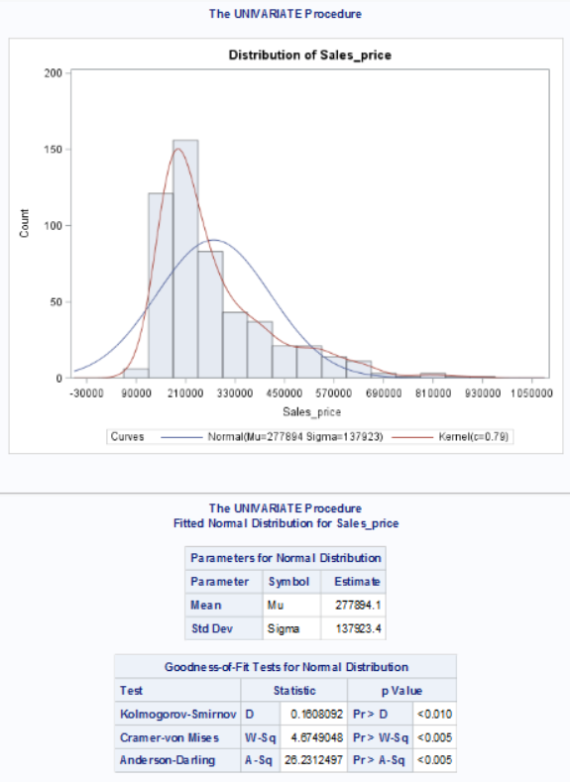

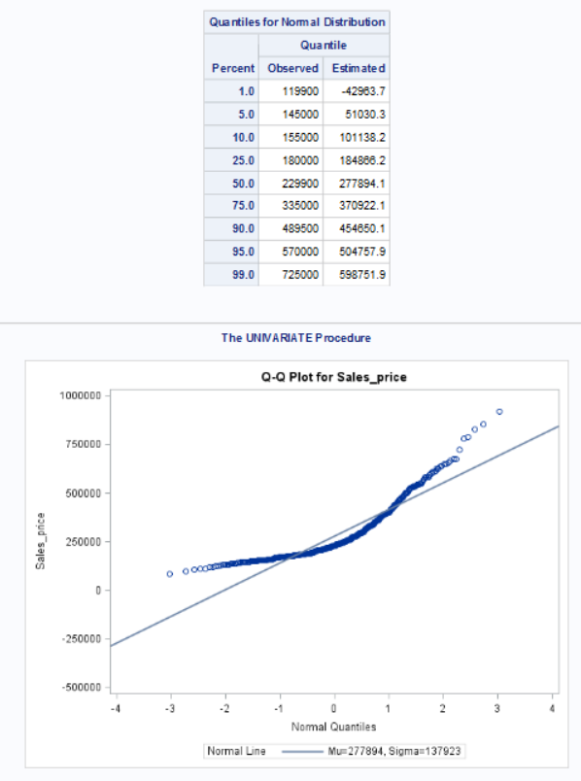

Figure : Displaying the UNIVARIATE Procedure output.



(see attachment for full output)

### The PROC PLOT Procedure

PROC PLOT is a procedure used to create normal scatter plots between 2 variables.

Code snippet:

**proc** **plot**;

plot Sales_price*Finished_square_feet='*';

plot Sales_price*Number_of_bedrooms='*';

plot Sales_price*Number_of_bathrooms='*';

plot Sales_price*Air_conditioning='*';

plot Sales_price*Garage_size='*';

plot Sales_price*Pool='*';

plot Sales_price*Year_built='*';

plot Sales_price*Quality='*';

plot Sales_price*Style='*';

plot Sales_price*Lot_size='*';

plot Sales_price*Adjacent_to_highway='*';

**run**;

Output:

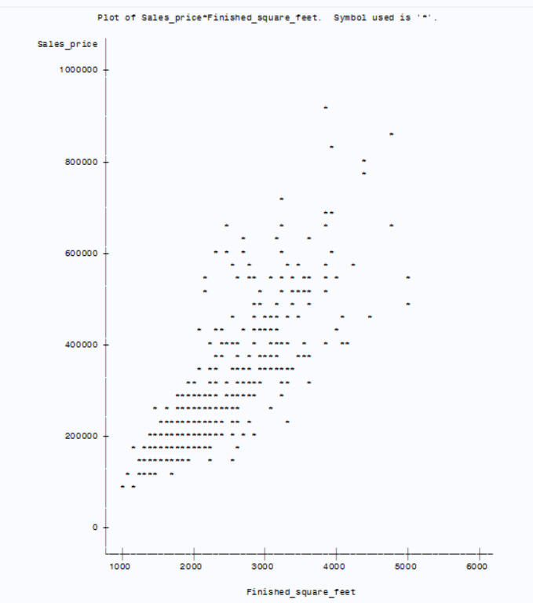

Figure : Displaying the scatter plot for Sales Price vs. Finished Square Feet.



(see attachment for full output)

Let’s add some regression lines in the above plots to get some sense of correlation between plotted variables. To do so, we need some advanced procedures to fulfill this requirement. Hence, the PROC SGPLOT comes into the picture which we will be discussing next.

### The PROC SGPLOT Procedure

PROC SGPLOT is a procedure used to create various types of plots, or data visualizations mentioned below:

1. Basic Plots--scatter, series, step, band, and needle

2. Fits and Confidence--loess, regression, penalized B-spline, and ellipse

3. Distributions--horizontal and vertical box plots, histogram, normal curve, and kernel density estimate

4. Categorizations--dot plot, horizontal and vertical bar charts, horizontal and vertical line charts

Let’s visualize some of the graphs mentioned above.

Code snippet:

**proc** **sgplot** data=libref.re;

reg Y=Sales_price X=Finished_square_feet;

**run**;

**proc** **sgplot** data=libref.re;

reg Y=Sales_price X=Number_of_bedrooms;

**run**;

**proc** **sgplot** data=libref.re;

reg Y=Sales_price X=Number_of_bathrooms;

**run**;

**proc** **sgplot** data=libref.re;

reg Y=Sales_price X=Air_conditioning;

**run**;

**proc** **sgplot** data=libref.re;

reg Y=Sales_price X=Garage_size;

**run**;

**proc** **sgplot** data=libref.re;

reg Y=Sales_price X=Pool;

**run**;

**proc** **sgplot** data=libref.re;

reg Y=Sales_price X=Year_built;

**run**;

**proc** **sgplot** data=libref.re;

reg Y=Sales_price X=Quality;

**run**;

**proc** **sgplot** data=libref.re;

reg Y=Sales_price X=Style;

**run**;

**proc** **sgplot** data=libref.re;

reg Y=Sales_price X=Lot_size;

**run**;

**proc** **sgplot** data=libref.re;

reg Y=Sales_price X=Adjacent_to_highway;

**run**;

Output:

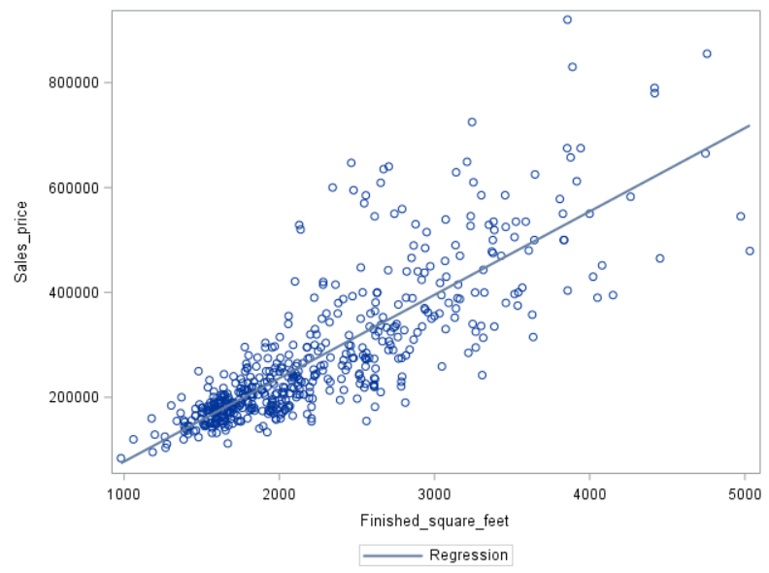

Figure : Displaying the SGPLOT Procedure output.



(see attachment for full output)

It’s time to deep dive into a correlation matrix where we will be checking the correlation between the regressors itself using the PROC CORR procedure discussed in the next section.

## Preparing the Input Variables for Prediction

Predictive modeling consists of various statistical and machine learning techniques aimed at establishing the relationship between an outcome variable and various predictor variables for purposes of predicting and/or explaining a future outcome. Two of these techniques, linear regression, and logistic regression, former will be discussed here.

Before preparing the input variables for predictive modeling, the analyst must first take measures to prevent overfitting of the predictive model. When a predictive model is constructed and its performance is then assessed using the same data on which the classifier was constructed, there is an inherent overestimate in its performance; consequently, it is unlikely that the model will perform as well when applied to the population of interest. To avoid overfitting, the analyst must split the data into two data sets--the **training data set** and the **validation data set** (or hold out data set). It must be addressed before preparing the input data for modeling in order to avoid information leakage.

### Missing values

A missing data value occurs when an observation has no value for a variable. Missing information can arise in various situations. When data is collected by way of a survey, respondents can refuse to answer a question or they may not have the information at hand. In many data collection situations, a variable may be blank simply because the scenario does not apply to that customer, business transaction, or hospital encounter.

Code snippet:

**proc** **means** data=libref.re NMISS N;

**run**;

Output:

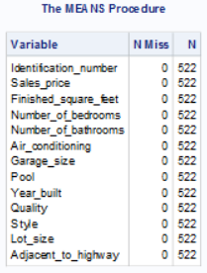

Figure : Displaying the missing values for all the regressor parameters.

As, we have no missing values in our dataset, so we are good to go ahead.

Note: In case of any missing values, PROC STDIZE procedure can be of much relief.

### Detecting and removing outliers

In general, an observation is considered an outlier if it is ‘far’ in distance from other observations. Depending on the situation, there are various ways to define that distance. When exploring a single variable, observation is considered an outlier if its distance from the middle 50 percent of the observations is more than 1.5 times the interquartile range (IQR). Specifically, observation is considered an outlier if its value falls outside of the lower and upper limits defined as follows:

Upper Limit = Q3 + 1.5IQR

Lower Limit = Q1 – 1.5IQR

Code snippet:



Output:

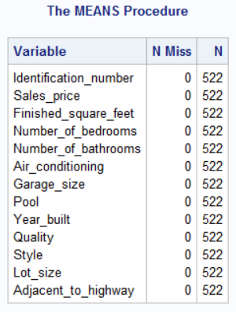

Figure : Dataset before removing outliers

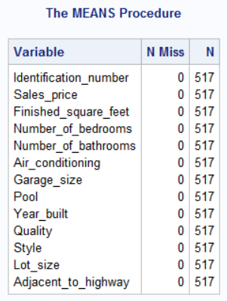

Figure : Dataset after removing outliers



(see attachment for complete output)

### Correlation between variables

The correlation coefficient ranges from -1.0 to +1.0 and is a measure of the strength and direction of the monotonic relationship between two ranked variables; monotonic refers to the fact that the direction of the relationship never changes and is either always positive, always negative, or always constant.

Code snippet:

**proc** **corr** data=libref.re;

var Sales_price

Finished_square_feet

Number_of_bedrooms

Number_of_bathrooms

Air_conditioning

Garage_size

Pool

Year_built

Quality

Style

Lot_size

Adjacent_to_highway;

**run**;

Output:

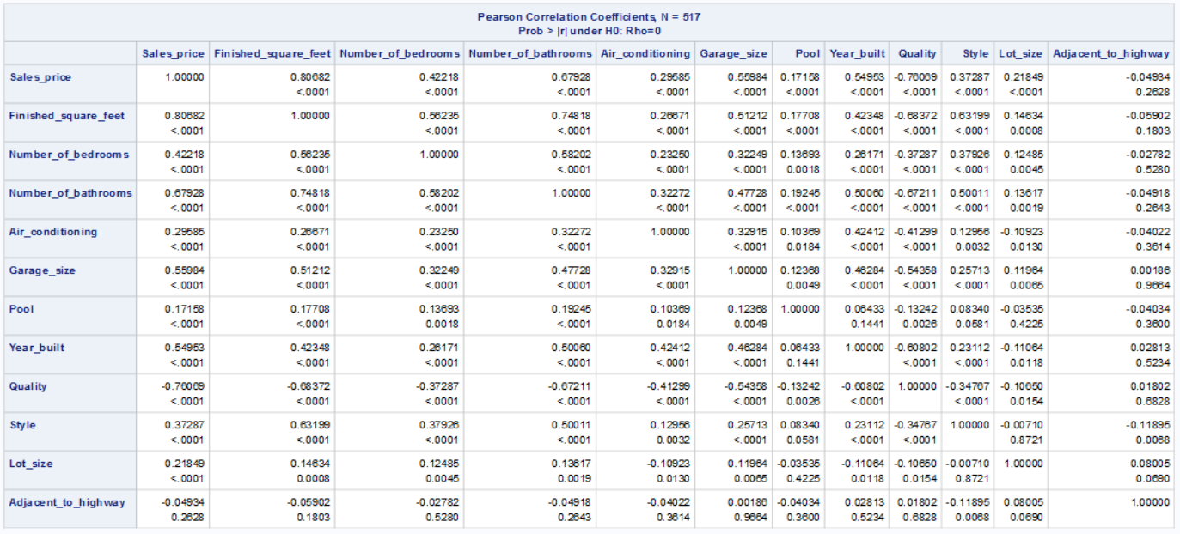

Figure : Displaying correlation between regressor variables and dependent variables.

We can infer from the above table that there is a correlation exist among regressor variables, this phenomenon is also known as multicollinearity, which may influence the model selection criteria, which will be discussed later in the following sections.

Effects of multicollinearity:

1. If some or all the predictor variables are correlated among themselves, the ability to obtain a good fit nor does it tend to affect inferences about mean responses or predictions of new observations.
2. The estimated regression coefficients tend to have large sampling variability when the predictor variables are highly correlated. Hence, the estimated regression coefficients tend to vary widely from one sample to the next when the predictor variables are highly correlated.
3. The simple interpretation of the regression coefficients as measuring marginal effects is often unwarranted with a highly correlated predictor variable.
4. When predictor variables are correlated, the marginal contribution of any one predictor variable in reducing the error sum of square varies, depending on which other variables are already in the regression model just as for regression coefficients.
5. Multicollinearity also affects the coefficients of partial determination through its effects on the extra sum of squares.
6. The high degree of multicollinearity among the predictor variables is responsible for the inflated variability of the estimated regression coefficients.
7. Multicollinearity does not materially affect the precision of the estimated mean response.

We can build a good model by eliminating regressors which add a very little contribution in enhancing the model performance. We can examine the process for a small number of regressors two or three, but in case of the number of regressors, let say more than 10, it would be tedious to do so. Hence, SAS came up with the automatic model selection procedure, which helps end-users to determine a good fit model through some process which will be discussed shortly.

## Model Selection

For any set of (p-1) predictors, [2]^(p-1) alternative models can be constructed. This calculation is based on the fact that each predictor can be either included or excluded from the model. For example: [2]^4 = 16 different possible subset models that can be formed from the pool of four X variables.

Model selection procedures, also known as subset selection or variables selection procedures, have been developed to identify a small group of regression models that are “good” according to a specified criterion. A detailed examination can then be made of a limited number of the more promising or “candidate” models, leading to the selection of the final regression model to be employed. This limited number might consist of three to six “good” subsets according to the criteria specified, so the investigator can then carefully study these regression models for choosing the final model.

To build a good model, various parameter needs to be examined before finalizing the model, few of them mentioned below.

1. Coefficient of multiple determination
2. Error Sum of Squares (SSE)
3. Coefficient of adjusted multiple determination
4. Mallows Criterion
5. Akaike’s Information Criterion (AIC)
6. Schwarz Bayesian Criterion (SBC)
7. PRESS Criterion

### Forward Stepwise Procedure

The forward stepwise regression procedure is probably the most widely used of the automatic search methods. It was developed to economize on computational efforts, as compared with the various all-possible-regression procedures. Essentially, this search method develops a sequence of regression models, at each step adding or deleting an X variable. The criterion for adding or deleting an X variable can be stated equivalently in terms of error sum of square reduction, coefficient of partial correlation, t* statistic, or F* statistic.



Code snippet:

**proc** **reg**;

model Sales_price = Finished_square_feet

Number_of_bedrooms

Number_of_bathrooms

Air_conditioning

Garage_size

Pool

Year_built

Quality

Style

Lot_size

Adjacent_to_highway/selection =rsquare

cp

adjrsq

mse;

model Sales_price = Finished_square_feet

Number_of_bedrooms

Number_of_bathrooms

Air_conditioning

Garage_size

Pool

Year_built

Quality

Style

Lot_size

Adjacent_to_highway /selection=stepwise;

**run**;

Output:

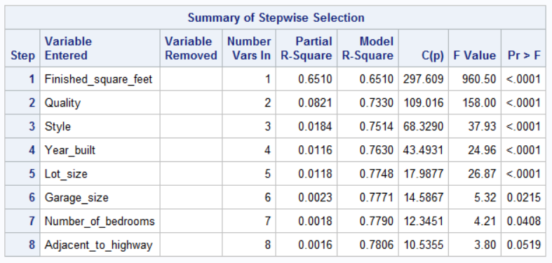

Figure : Displaying the final regressor subset using the Forward Stepwise Procedure.



(see attachment for complete output)

### Forward Selection Procedure

The forward selection search procedure is a simplified version of the forward stepwise regression, omitting the test whether a variable once entered into the model should be dropped.

Code snippet:

**proc** **reg**;

model Sales_price = Finished_square_feet

Number_of_bedrooms

Number_of_bathrooms

Air_conditioning

Garage_size

Pool

Year_built

Quality

Style

Lot_size

Adjacent_to_highway/selection =rsquare

cp

adjrsq

mse;

model Sales_price = Finished_square_feet

Number_of_bedrooms

Number_of_bathrooms

Air_conditioning

Garage_size

Pool

Year_built

Quality

Style

Lot_size

Adjacent_to_highway /selection=forward;

**run**;

Output:

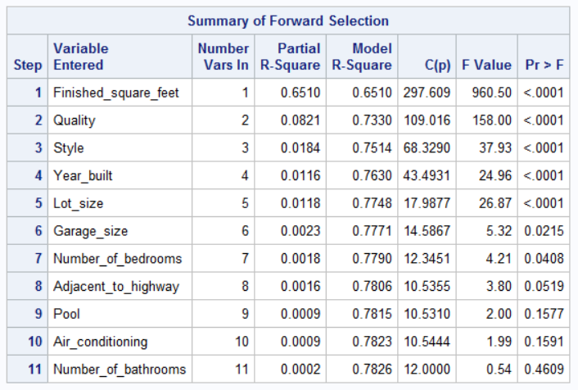

Figure : Displaying the final regressor subset using the Forward Selection Procedure.



(see attachment for complete output)

### Backward Elimination Procedure

The backward elimination search procedure is the opposite of the forward selection procedure. It begins with the model containing all potential X variables and identifies the one with the largest P-value. If the maximum P-value is greater than a predetermined limit, that X variable is dropped. The model with the remaining (P-2) X variables is then fitted, and the next candidate for dropping is identified. This process continues until no further X variables can be dropped. A stepwise modification can also be adapted that allows variables eliminated earlier to be added later; this modification is called the backward stepwise regression procedure.

Code snippet:

**proc** **reg**;

model Sales_price = Finished_square_feet

Number_of_bedrooms

Number_of_bathrooms

Air_conditioning

Garage_size

Pool

Year_built

Quality

Style

Lot_size

Adjacent_to_highway/selection =rsquare

cp

adjrsq

mse;

model Sales_price = Finished_square_feet

Number_of_bedrooms

Number_of_bathrooms

Air_conditioning

Garage_size

Pool

Year_built

Quality

Style

Lot_size

Adjacent_to_highway /selection=backward;

**run**;

Output:

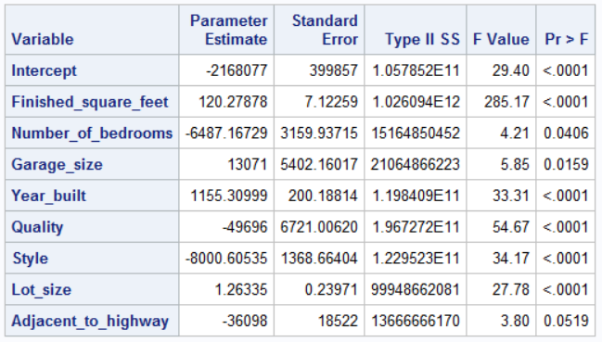

Figure : Displaying the final regressor subset using the Backward Elimination Procedure.

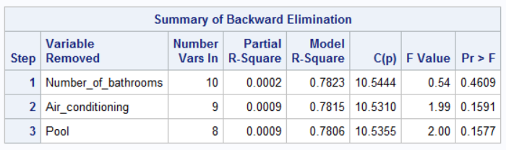

Figure : Displaying the rejected regressor subset using the Backward Elimination Procedure.



(see attachment for complete output)

As per the above 3 models discussed, the forward stepwise and Backward elimination procedure provides the same subset as a final “best” model. Let’s run the final Multiple Regression model with the below regressors predicted as the best regressors with the above automatic model selection procedures.

* Number_of_bedrooms
* Finished_square_feet
* Air_conditioning
* Garage_size
* Year_built
* Lot_size
* Quality
* Style

Code snippet:

**proc** **reg**;

model Sales_price = Finished_square_feet

Number_of_bedrooms

Air_conditioning

Garage_size

Year_built

Quality

Style

Lot_size/all;

**run**;

**proc** **glm**;

model Sales_price = Finished_square_feet

Number_of_bedrooms

Air_conditioning

Garage_size

Year_built

Quality

Style

Lot_size;

**run**;

Output:



(see attachment for complete output)

Copyright documentation

<https://libguides.library.kent.edu/SAS/ViewContents>

<https://www.sas.com/store/prodBK_69531_en.html?storeCode=SAS_US>

<https://support.sas.com/en/documentation.html>